**Battle of the Neighborhoods – A Case Study of African Restaurants and Cuisines in New York City: Final Report**

**Problem Description and Background**

New York city is the most populous city in the United States. It is diverse and is the financial capital of USA. It is multicultural. It provides lot of business opportunities and business friendly environment. It has attracted many different players into the market. It is a global hub of business and commerce. The city is a major center for banking and finance, retailing, world trade, transportation, tourism, real estate, new media, traditional media, advertising, legal services, accountancy, insurance, theater, fashion, and the arts in the United States. This also means that the market is highly competitive. As it is highly developed city so cost of doing business is also one of the highest. Thus, any new business venture or expansion needs to be analyzed carefully. The insights derived from analysis will give good understanding of the business environment which help in strategically targeting the market. This will be ideal for any kind of investment. The City of New York is famous for its different restaurants, but very few African restaurants are within reach. If anyone plants a new African restaurant in a good location and serve all the most liked African and some American foods, we will see some returns to the investments that will be made. Various factors need to be studied to decide on the Location of the restaurant.

**Data Description**

The data that will be used in solving this problem is the New York json data file that was used in one of the assignments. The data will be imported and arranged properly. It will be read into a pandas data frame and the geographical description (coordinates and maps of NYC and selected boroughs) of the data will be conducted. The following data can be read from the file: borough, neighborhood, latitude, longitude. In addition, I would use my Foursquare API credentials to explore the neighborhoods within the selected boroughs. This will help determine the suitable location for opening the African restaurant.

**Methodology**

This section of the report is represented from step 1 to step 6 in the Jupyter notebook. Every step and sub-steps have been explained in detail. These steps are summarized below.

***Step 1 (Import Libraries)***: In this step, the libraries necessary to perform the study are imported. Some of the important libraries are pandas, matplotlib, json, and folium to mention a few. The libraries that have not been installed was installed before importation.

***Step 2 (Import and Arrange Data)***: In this step, the New York city data is a json file. The json library was used to import the data. The data is then transformed into a pandas data frame. This is essentially transforming the data of nested Python dictionaries into a pandas data frame. Empty data frames are created, and the data looped through to fill the data frame one row at a time. After this, the new dataframe is viewed with the. head*()* and *.shape* functions.

***Step 3 (Geographical Exploration of New York City)***: In this step, the geopy library used to get the latitude and longitude values of New York City. After this, the folium library used to visualize the map of New York City which is shown in figure 1.

***Step 4 (Geographical Exploration of Three New York Boroughs)***: In this step, the original dataframe is sliced to create new dataframes for Manhattan, Brooklyn, and Queens. The reason for selecting these boroughs are presented in the discussion section. After creating the new dataframes, their coordinates are obtained and then their maps are visualized. Figure 2 shows the map of Brooklyn. All other maps are found in the notebook.

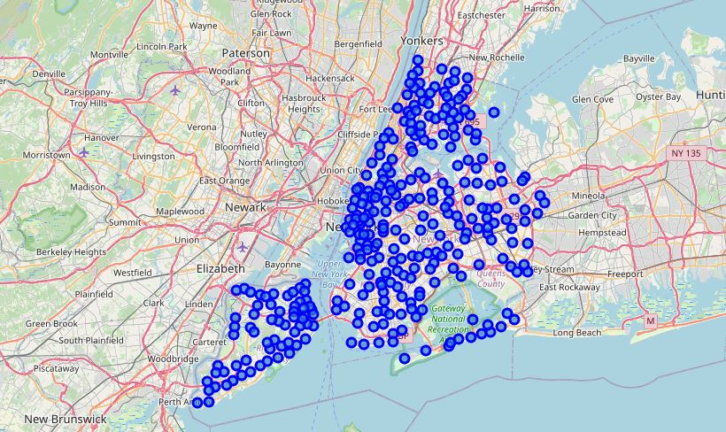

**Figure 1: Map of New York City**

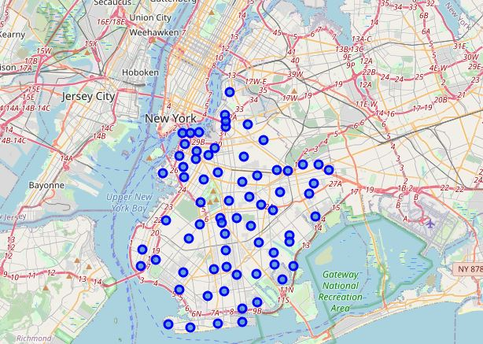

**Figure 2: Map of Brooklyn**

***Step 5 (Using Foursquare API to Explore the Boroughs***): In this step, I established my Foursquare API credential. These credentials are client ID, client secret, and version. After establishing these credentials, the Foursquare API was used to explore the selected boroughs in NYC. First, the coordinates of the first neighborhood in each borough was obtained. Next, a get-category-type function was used to extract the category information for the first 100 venues from these boroughs, after which the json files are cleaned and structured into a pandas dataframe.

***Step 6 (Explore Neighbourhoods in Manhattan, Brooklyn, and Queens)***: In this step, a get-nearby-venue function is created to repeat the whole step 5 for all the venues in the neighbourhoods of the boroughs. After this, each neighbourhood is evaluated for the purpose of locating a new African restaurant.

**Results**

The results of this work are presented in step 6. In this step, the Foursquare API was used to evaluate and explore the neighborhoods within Manhattan, Brooklyn, and Queens. The results show that: In Manhattan, there are 3 African restaurants all in the Central Harlem neighborhood. In Brooklyn, there is only 1 African restaurant in Ocean Hill neighbourhood In Queens, there is no African restaurant on record.

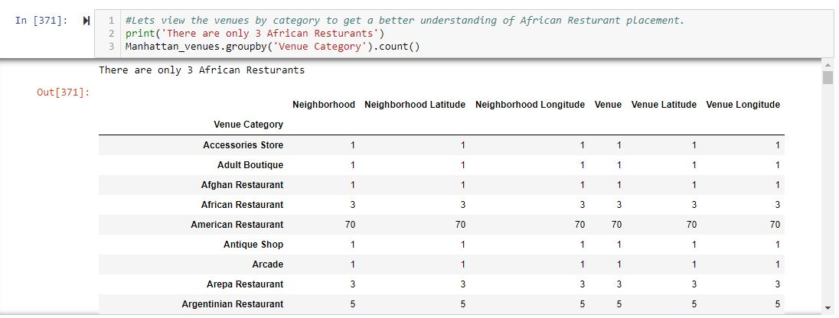

**Figure 3: Code and result of the number of African restaurants in Manhattan**

Figures 3 to 6 shows the codes and results of the number of African restaurants and their locations in Manhattan and Brooklyn. The results for Queens are not presented here because it did not turn out any result. However, the codes can be found in the notebook.

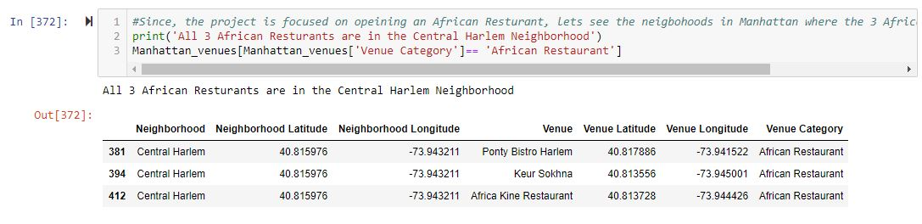

**Figure 4: Code and results of location of African restaurants in Manhattan**

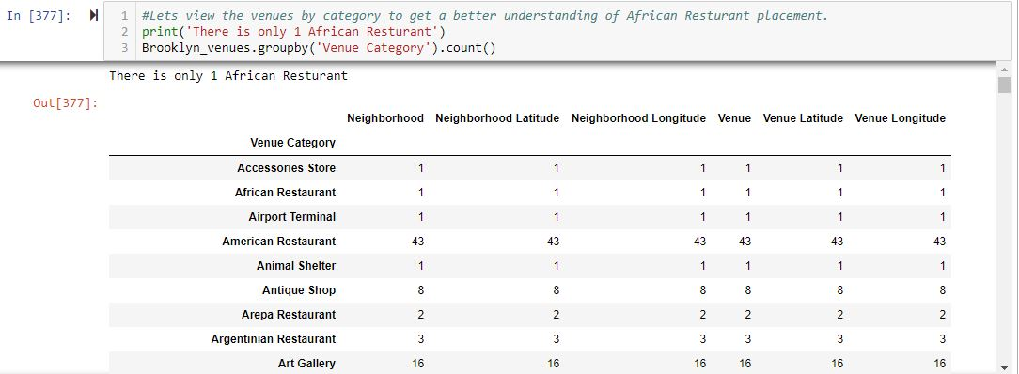

**Figure 5: Code and result of the number of African restaurants in Brooklyn**



**Figure 6: Code and results of location of African restaurants in Brooklyn**

**Discussions**

The three boroughs were chosen because Manhattan is the biggest commercial borough. Queens has the largest land mass (108.1 sq miles) followed by Brooklyn (69.5 sq miles). The two busiest airports in NYC are located in Queens.

Furthermore, according to the demographics of New York City (Wikipedia, 2019), 2 out of every 5 residents in NYC live in Brooklyn and 1 out of every 5 residents live in Queens. Thus, the target borough audience for opening a new African restaurant is in Queens and Brooklyn. Manhattan is considered because of its commercial presence. Given the result, a recommendation for establishing an African restaurant in Queens NYC is made. This rule out the competition challenge and repetition of restaurant types and cuisines.

**Conclusion**

In this study, NYC data was evaluated to determine the most suitable borough for opening an African restaurant. Several python libraries and methods were used to read and evaluate the data. Foursquare API credentials were also used to investigate the neighborhoods in the selected boroughs. The reasons for selecting three boroughs have been provided in the discussion. This work can be extended to the remaining two boroughs. At the end of the study, Queens borough appears to be the most suitable borough for locating the proposed African restaurant.